**UNIT IV**

**TECHNICAL COMMUNICATION SKILLS**

* **Interview skills; Seminar/Conferences Presentation skills: Focus; Content; Style; Argumentation skills: Devices: Analysis; Cohesion & Emphasis; Critical thinking; Nuances: Exposition narration & Description; effective business communication competence: Grammatical; Discourse competence: combination of expression & conclusion; Socio-linguistic competence: Strategic competence: Solution of communication problems with verbal and nonverbal means.**
* **Conducting Meeting**
* **Mobile Etiquette**
* **Voice Modulation**

**Interview skills**

An interview is an interaction between two or more persons for a specific purpose, in which the interviewer asks the interviewee specific questions in order to assess his/her suitability for recruitment. Admission, promotion. It can also be a meeting in which a journalist asks somebody questions to determine their opinions.

Although the nature of interviews may be different for different organizations, several rules are common for all. For example, for any job interview, one needs to prepare or update one’s resume, know the profile of the company, prepare commonly asked questions and answers etc.Depending on the objective and nature, interviews can be categorized into the following types: Job, Persuasive, Evaluation/Appraisal, Exit, Counselling, Disciplinary, Media, Termination and so on.

**Objective of Interview**

Generally interviews are conducted to achieve some of the following objectives:

1. To select a person for a specific task
2. To monitor performance
3. To collect information
4. To exchange information
5. To counsel

**Interview Tips**

Even the smartest and most qualified job seekers need to prepare for their job interview. Interview skills are learned, and there are no second chances to make a great first impression. These 10 interview tips will teach you how to answer interview questions and convince the hiring manager that you are the one for the job.

1. **Practice good nonverbal communication**

It's about demonstrating confidence: standing straight, making eye contact and connecting with a firm handshake. That first nonverbal impression can be a great beginning—or quick ending—to your interview.

1. **Dress for the job or company**

Today's casual dress codes do not give you permission to dress as "they" do when you interview. It is important to know what to wear to an interview and to be well-groomed. Whether you wear a suit or something less formal depends on the company culture and the position you are seeking. If possible, call to find out about the company dress code before the interview.

1. **Listen**

From the very beginning of the interview, your interviewer is giving you information, either directly or indirectly. If you are not hearing it, you are missing a major opportunity. Good communication skills include listening and letting the person know you heard what was said. Observe your interviewer, and match that style and pace.

1. **Don't talk too much**

Telling the interviewer more than he needs to know could be a fatal mistake. When you have not prepared ahead of time, you may ramble when answering interview questions, sometimes talking yourself right out of the job. Prepare for the interview by reading through the job posting, matching your skills with the position's requirements and relating only that information.

1. **Don't be too familiar**

The interview is a professional meeting to talk business. This is not about making a new friend. Your level of familiarity should mimic the interviewer's demeanor. It is important to bring energy and enthusiasm to the interview and to ask questions, but do not overstep your place as a candidate looking for a job.

1. **Use appropriate language**

It's a given that you should use professional language during the interview. Be aware of any inappropriate slang words or references to age, race, religion, politics, or sexual orientation—these topics could send you out the door very quickly.

1. **Don't be cocky**

Attitude plays a key role in your interview success. There is a fine balance between confidence, professionalism, and modesty. Even if you're putting on a performance to demonstrate your ability, overconfidence is as bad, if not worse, as being too reserved.

1. **Take care to answer the questions**

When interviewers ask for an example of a time when you did something, they are asking behavioral interview questions, which are designed to elicit a sample of your past behavior. If you fail to relate a specific example, you not only don't answer the question, but you also miss an opportunity to prove your ability and talk about your skills.

1. **Ask questions**

When asked if they have any questions, most candidates answer, "No." Wrong answer. Part of knowing how to interview is being ready to ask questions that demonstrate an interest in what goes on in the company. Asking questions also gives you the opportunity to find out if this is the right place for you. The best questions come from listening to what you're asked during the interview and asking for additional information.

1. **Don't appear desperate**

When you interview with the "please, please hire me" approach, you appear desperate and less confident. Reflect the three Cs during the interview: cool, calm, and confident.

**Seminar/Conferences Presentation skills: Focus; Content; Style**

Presentations skills and public speaking skills are very useful in many aspects of work and life. Effective presentations and public speaking skills are important in business, sales and selling, training, teaching, lecturing, and generally feeling comfortable speaking to a group of people.

Developing the confidence and capability to give good presentations, and to stand up in front of an audience and speak well, are also extremely helpful competencies for self-development and social situations.

Presenting information clearly and effectively is a key skill in getting your message across. Today, presentation skills are required in almost every field, and most of us are required to give presentations on occasions. While some people take this in their stride, others find it much more challenging.

**Be yourself**

Figure out what presentation style is most natural for YOU. Reflect on the talks you've seen and consider which aspects you like or dislike. For example, if you think showing video clips is not your style, avoid using them. Or if you like how people use themes and a common metaphor throughout their talk, you can try to incorporate this into your talk as well.

**Preparing slides**

When it comes to slides, less is more. Don’t try to rush through 100 slides in 20 minutes. A good rule of thumb is 1 slide per minute.Here is one way to divide your slides: The first slide should introduce the title of your talk, who you are and where you are from. To get the audience primed for your talk, include a slide introducing the main question and findings to be discussed. It is also important to include a slide outlining the flow of the talk to provide a sense of predictability. Background can be covered in two slides asserting the problem statement, reason why you are interested in the question, and prior work. Methods can be covered briefly in one slide (additional information can be provided later if requested). The bulk of your talk (4 slides) should be focused on the results. One slide summarizing your hypotheses and findings should follow. Finally, one slide can be dedicated to discussing future work or limitations.

**Be clear and concise**

Structure your talk around 3-5 "take away" points you want the audience to remember, which can be repeated multiple times. This will help keep unnecessary details to a minimum and allow you to highlight your primary message more clearly. Additionally, avoid using jargon and technical language. You want a broad audience, not just experts in your field, to be able to understand your results.

**Engage your audience with illustrations**

A picture (or graph) is worth a thousand words. Keep your slides light on text and heavy on figures, but avoid overly complicated figures that are hard to comprehend. The purpose of you giving your talk in person is to explain to the audience what the graph illustratesin an easy-to-understand manner.

**Handling the Q&A**

For some, the most nerve-wracking part of a presentation is after you have delivered your prepared talk and are awaiting unknown questions. However nervous you may feel (which is completely normal), rest assured that no one is more of an expert on your study than you are. You designed and implemented the study and conducted the analyses. If you still feel nervous about answering questions, prepare additional slides that can answer questions you anticipate. A useful way to deal with questions you are not prepared for is to say you want to think about the insightful question and are willing to discuss it in more detail individually after the presentation.

**Practice makes perfect!**

As researchers we know this is fact yet we often ignore it. Allow yourself enough time to practice your talk at least three times before going live on stage, focusing on transitions, eye contact, and rate of speech, which are often problematic when first giving a talk. Practice your talk in front of a diverse audience, including your lab mates who likely know a lot about your research and can give detailed comments, as well as friends or family outside of your research area who can provide a more general perspective. It may also be useful to spend some time toying with any equipment you may use, such as a laser pointer or projector, so that you don't waste time during your presentation figuring out how to use it. The more comfortable you feel during a talk, the clearer your message will be to the audience.

**Argumentation skills: Devices: Analysis; Cohesion & Emphasis**

Argumentation is the thought process used to develop and present arguments. It is closely related to critical thinking and reasoning. Argument skills belong among the essential 21st century cognitive skills. We face complex issues that require careful, balanced reasoning to resolve.

**6 key argument-winning tools.**

Keep in mind: Winning an argument doesn’t necessarily mean being the only one who’s right. If your goal is to resolve a conflict, then to “win” might mean you “lose":

Know your facts. How many times have you made a claim about some piece of trivia only to realize, as soon as you’ve made that claim, that you’re completely wrong? Inevitably, someone challenges you, but because you don’t want to “lose,” you continue to stick to your guns. This is not an ideal way to win (or enter) an argument. In the TV show Psych, the lead character often says when challenged, unconvincingly, “I’ve heard it both ways.” Stop and think before you make such bloopers yourself, and you’ll be less likely to lose, whether the matter is trivia or a truly important career or relationship challenge.

Be ready to see the other person’s perspective. You don’t have to agree with a foe in order to see his or her perspective. However, if you want to win an argument, you do need to be able to see the world the way your opponent does. Stepping into the mental set of those you argue with allows you to figure out what’s influencing them. Perhaps they’re feeling threatened, anxious, or annoyed. Perhaps they know something that you don’t. In any case, showing empathy will lower the temperature of the debate and allow both of you to come to resolution.

If you can’t be open-minded, at least seem that way. Becoming defensive is one of the worst ways to win an argument. Don’t let your opponent sense that you’re digging into your position without being willing to consider alternatives. If you appear to be giving the other side’s position a thoughtful review, then the solution you propose will seem to be far more sensible. Furthermore, your opponent may come to your side without your having to do anything other than listen. By letting your opponent speak, you may allow the situation to naturally resolve itself.

Keep your emotions under control. From the Halperin review, it’s clear that emotions play an important role in conflict by altering how you appraise the situation. In addition, Halperin also pointed out that being able to regulate your emotions is equally important. If you lose your temper, you’ll only antagonize your opponent, which will further heighten his or her wrath, and the process can only escalate upwards. Don’t worry that you'll seem weak by becoming calm in the midst of an argument—you’ll gain points by showing that you can exercise self-control. Who knows, the argument may even end right then and there, once both of you take a more reasoned perspective.

Remain hopeful that the argument can be resolved. Arguments, by definition, involve negative emotions. In the midst of a screaming fest, it might be hard to see yourself coming out on the other side with your dignity intact. However, invoking the feeling of hope allows you to think more clearly, leading to the possibility that you’ll win by sheer force of logic. As Halperin points out, hope allows you to "come up with creative solutions to the disputes at the core of the conflict” (p. 71). In other words, you may see a way out of what seems to be a locked battle of wills once you believe that there is a way out. This is what happens in ordinary problem-solving, when thinking outside of the box can help all sides come up with a solution. Such an “aha” moment in an argument can lead you straight to victory.

Respect your opponent. Many arguments have no clear victors: You may get your way, but your relationship or situation is the worse for it. A successful argument within a relationship remains compartmentalized. Don’t let it lead to questioning the entire basis of the relationship. By the same token, don’t insult or degrade your opponent. Even if the individual is someone you’ll never see again, it’s still important to show that you meant “nothing personal” in the dispute.

**Critical thinking; Nuances: Exposition narration & Description**

Critical thinking is the act of analyzing facts to understand a problem or topic thoroughly. Critical thinking often occurs in order of a few steps from identifying a problem or issue to developing a solution. Here are common steps that occur when using critical thinking for problem solving:

1. Identify a problem or issue
2. Create inferences on why the problem exists and how it can be solved
3. Collect information or data on the issue through research
4. Organize and sort data and findings
5. Develop and execute solutions
6. Analyze what solutions worked or didn’t work
7. Identify ways to improve the solution

Part of being a good critical thinker is being objective. That means analyzing the problem without allowing emotions or assumptions to influence how you think about it. Instead, you should only analyze the problem based on the context and facts you are able to collect.

Critical thinking skills are essential in every industry at every career level, from entry-level associates to top executives. Good critical thinkers will work both independently and with groups to solve problems.

Why are critical thinking skills important?

Critical thinking skills are important because they help businesses run smoothly by solving problems, developing solutions and creating new ideas. Many areas of improvement like process inefficiencies, management or finances can be improved by using critical thought. Because of this, employers value and seek out candidates who have demonstrated strong critical thinking skills.

For example, if you’re working in human resources and must resolve a conflict between two employees, you will use critical thinking to understand the nature of the conflict and what action should be taken to resolve it.

Critical thinking is the analysis of facts to form a judgment. The subject is complex, and several different definitions exist, which generally include the rational, skeptical, unbiased analysis, or evaluation of factual evidence.There are skills that have the capability to greatly improve your capacity to make objective, effective choices and arguments, and those are critical thinking skills. Without these skills, arguments can often be one-sided. Criticism can feel like a personal attack on your character rather than an opportunity to open up dialogue and communicate productively.

Critical thinking has been variously defined as follows:

"The process of actively and skillfully conceptualizing, applying, analyzing, synthesizing, and evaluating information to reach an answer or conclusion"

"Disciplined thinking that is clear, rational, open-minded, and informed by evidence"

"Purposeful, self-regulatory judgment which results in interpretation, analysis, evaluation, and inference, as well as explanation of the evidential, conceptual, methodological, criteriological, or contextual considerations upon which that judgment is based"

"Includes a commitment to using reason in the formulation of our beliefs"

The skill and propensity to engage in an activity with reflective scepticism.

Thinking about one's thinking in a manner designed to organize and clarify, raise the efficiency of, and recognize errors and biases in one's own thinking. Critical thinking is not 'hard' thinking nor is it directed at solving problems (other than 'improving' one's own thinking). Critical thinking is inward-directed with the intent of maximizing the rationality of the thinker. One does not use critical thinking to solve problems—one uses critical thinking to improve one's process of thinking.

"An appraisal based on careful analytical evaluation"

Contemporary critical thinking scholars have expanded these traditional definitions to include qualities, concepts, and processes such as creativity, imagination, discovery, reflection, empathy, connecting knowing, feminist theory, subjectivity, ambiguity, and inconclusiveness. Some definitions of critical thinking exclude these subjective practices

**1. Become a self-critic.**

The very first and most important step for developing critical thinking skills is becoming a critic of your own thoughts and actions. Without self-reflection, there can’t be growth. You can break down your own thoughts by asking yourself why you believe something. When you do this, you need to clarify your thoughts by assessing this information objectively and finding a solid logic to what you believe, rather than just a muddled idea. Why do I believe this? Can I think of examples in my life when this proved true or false? Am I attached to this idea emotionally? Why? When we self-reflect, we are able to observe how we respond to a situation, in our minds and out loud.

Another aspect of becoming a self-critic is acknowledging your strengths, weaknesses, personal preferences and biases. When you know this information, you can understand why you approach certain situations from a specific perspective, and then you can step around that viewpoint because you are aware of its presence.

**2. Active listening.**

Thinking and listening are nearly impossible to do at the same time. To become a critical thinker, you need to be able to listen to others’ ideas, arguments and criticisms without thinking of your response or reaction while they are speaking. You can’t properly absorb the information someone is trying to convey to you if you don’t take the time to truly listen. Listening allows us to feel empathy. We hear someone else’s story, struggles, ideas, successes and passions, and how they reached them. When we hear their perspective, we can take that information and analyze it. When we use active listening skills, we can fully understand what someone is trying to tell us because that conversation continues until all parties can reiterate what the other is trying to say.

**3. Analyzing information**.

Analyzing information is paramount for critical thinking. No one thinks critically at all times. Sometimes our joy, anger, sadness or other emotions are too great, and other times we struggle to focus on the central issue at hand. To reach success, we need to analyze the information before us, whether it is information in our mind or being shared by others. We can break it down by assessing what is being said, and ensuring that we clearly understand what it is that needs to happen. Then we can dissect and appraise all arguments, including our own, and think about how the decisions would impact others, as well as the bottom line. When we can step back and analyze an argument, it allows us to approach it from an objective viewpoint.

**4. Nonviolent communication.**

Critical thinking isn’t much help if you can’t communicate in a nonviolent, productive way. When listening and analyzing different arguments, you first need the ability to recognize valid logic. Then you need to be able to communicate with other people in a productive way. The basis of nonviolent communication is compassion, observation and collaboration. When we approach any scenario with compassion, we are already in a peaceful mindset, rather than a defensive one. When we observe, we can observe our arguments and others without judgment and evaluation. We can detach our emotions from an idea. He doesn’t like my idea, so he must not like me. And collaboration naturally happens when everyone comes into the process with a compassionate, open mind, with the focus on solving the objective at hand rather than protecting anyone’s ego.

**5. Developing foresight**.

The ability to predict the future impact of a decision is foresight. Foresight is a critical component for success in all aspects of your life. When you move somewhere, you plan ahead to see what the job outlook is and the safety of a neighborhood. If you are moving a business, it is wise to examine the impact of that decision. Will it be too far for some of your talented employees to drive? Will you lose business because of the change? What will you gain? Every decision should be weighed carefully, with consideration of how the choice affects your bottom line, but also for the people who are working toward success alongside you.

Critical thinking requires the ability to reflect on one’s own beliefs, as well as someone else’s ideas, and then see the connections between those things. It requires the ability to actively listen to others, to assess, dissect and appraise arguments, and to separate intense emotions from the topic at hand.

**Critical thinking skills list and examples**

There are several various critical thinking skills you may find valuable to include on your resume. Here are a few examples:

1. **Observation**

Observational skills are the starting point for critical thinking. Employees who are observant can quickly sense and identify a new problem. Those skilled in observation are also capable of understanding why something might be a problem, and may even be able to predict when a problem might occur before it happens based on their experience.

2. **Analysis**

Once a problem has been identified, analysis skills become essential. The ability to analyze the situation includes knowing what facts, data or information about the problem are important. You will also find analysis is an essential skill to eventually solving the problem.

3**. Inference**

Inference is a skill that involves drawing conclusions about the information you collect and may require you to possess technical or industry-specific knowledge or experience. When you infer information about a situation, that means you are developing answers based on limited information. For example, a car mechanic may need to utilize inference skills to determine what is causing a car’s engine to stall at seemingly random times.

4**. Communication**

Communication skills are important when it comes time to explain and discuss issues and their possible solutions with colleagues and other stakeholders. Communication is an important skill to have and improve on for many purposes at work including critical thinking.

5. **Problem solving**

After you’ve identified a problem, analyzed it and discussed possible solutions, the final step is to execute the solution. Problem solving often requires critical thinking to implement the best solution and understand whether or not the solution is working as it relates to the goal.

**How to improve your critical thinking skills**

While you might already possess many of the skills above, you might also consider your areas for improvement—especially for specific skills listed on a job description you’re applying for. It’s possible to improve your critical thinking skills through practice and extended educational opportunities.

**To improve your critical thinking skills, consider taking some of the following steps:**

Expand your industry-specific or technical skills to help you more easily identify problems

Take additional courses in your industry that require critical thinking and analysis

Actively volunteer to solve problems for your current employer

Seek advice from professionals in your field or desired industry

Play solo and cooperative games that require critical thinking skills, such as analysis and inference

Asking a friend or colleague to assess your current skill set can also help provide you with an objective view of your strengths. You may find it necessary to practice your critical thinking skills to improve the strength of your resume, or to help with career advancement.

**Effective business communication competence**

Effective business communication skills are vital to successful co-worker and customer interactions. Both the speaker and the listener share responsibility of making the message clear, but effective communication goes far beyond simple speech and hearing. Body language, tone of voice, word choice, message clarification and communication style all come into play, and can make the difference between success and failure in interpersonal transactions and interactions.

**Effective Speaking Skills**

Speakers must learn to articulate their message in a way the listener can understand, delivering it in a manner that is consistent with the message itself. Serious issues are best delivered in a serious tone, but with regard to the known or potential reaction of the listener. The reaction of the listener to both good or bad news can be directly controlled by the speaker, as long as the word choice and delivery are carefully considered. One part of effective speaking is knowing your listeners and how they may react, or delivering your message in a generic fashion if the listeners are not known.

**Active Listening by both Speaker and Listener**

Active listening is practiced by both the speaker and listener in effective communication. Active listening on the listener's part involves eye contact, nods, gestures and brief comments to show understanding. On the speaker's part, these gestures and comments are clues to the listener's reaction and comprehension. If the listener seems confused, the speaker may re-evaluate the wording or delivery of the message, and listeners must take it upon themselves to ask questions, validate what is being said and provide input if necessary.

**Asking Open-Ended Questions**

Questions asked by both the speaker and listener must be of the open-ended type – those that cannot be answered by a yes or no. Open-ended questions encourage further communication, dialogue and understanding, and can help all involved in the conversation to further investigate and clarify the message.

**Recognizing and Deciphering Body Language**

Recognizing and deciphering body language is both an art and a science. Eye movement and contact, stance, posture, facial expressions, fidgeting and other body language can sometimes give clues to the speaker and listener alike. If the tone of a speaker's voice is calm but his facial expression or posture is tense, the message can be confusing to the listener. Conversely, a listener who fidgets or does not make eye contact can give the speaker the impression that the listener is bored or not paying attention.

**Choosing Communication Methods**

In the modern business world, people communicate by text, phone, email, written correspondence and verbal communication. In effective communication, you must choose the communication method best suited for the message. Businesspeople who are articulate speakers may not be articulate writers, so the message in email and and written correspondence can sometimes be misconstrued. The same goes for writers who can craft detailed communications in written form, but choke when it comes to verbalizing.

Learning to be eloquent with all forms of communication methods may not be the easiest task, but the effective communicator knows her limitations and chooses the medium to match the mCommunication Competence Components

Researchers have broken down the characteristics of competent communicators into four (4) areas: self-awareness, adaptability, empathy, cognitive complexity.

Self-awareness means being aware of your own communication behaviors. Part of this is self-monitoring, which means that you observe your own communication behaviors and ensure they are appropriate to the situation. As an example, if you are someone who tends to use foul language, you would self-monitor while you're in a place of religious worship -- such as a church, temple, or mosque -- and refrain from such language usage in this environment.

Adaptability is the ability to adapt your communication to the environment you're in. That is, you wouldn't communicate in the same way to your closest friends as you would to your co-workers. Rather, while you're at work, you would adapt your communication behaviors to the norms and standards of the communication environment at work, and when you're with your friends, you adapt to that social environment accordingly.

Empathy means that you communicate with another person while putting yourself in that person's shoes, so to speak. For example, if your friend has just announced he is getting a divorce, you would consider that friend's frame of mind and refrain from bringing up how great your own significant relationship is at the moment, aware that such statements will likely only serve to make your friend feel worse about his or her own challenging situation.

Cognitive complexity is the idea that another's communication behavior can have multiple sources. This means that when someone is sharp with you, it could be from something you've done, yes, and perhaps that person is reacting to you. However, it could also be a result of that person's physical well-being at the moment -- perhaps s/he has a headache or didn't get enough sleep the night before -- or something in that person's life that is weighing on him or her at the moment.

**Socio-linguistic competence**

Sociolinguistic competence refers to the ability to use language that is appropriate to social contexts. Alptekin (2002, p. 58) explains that social context refers to culture-specific contexts that include the norms, values, beliefs, and behavioural patterns of a culture. For example, thanking a friend in a formal speech is different from how it is done over a meal.

It also refers to the ability to select topics that are appropriate for a communicative event. For example, expressing strong views about politics and religion over dinner is generally avoided. This rule is also moderated depending on the relationship between the guest and the host. If politics and religion are their favourite topics and if they know each other very well, these topics might well be appropriate.

**Topic: Conducting Meeting**

**Meeting – Basics**

* A meeting is a formal or informal deliberative assembly of individuals called to debate certain issues and problems, and to take decisions. Formal meetings are held at definite times, at a definite place, and usually for a definite duration to follow an agreed upon agenda.
* Meetings may occur face-to-face or virtually, as mediated by communications technology, such as a [telephone conference call](https://en.wikipedia.org/wiki/Conference_call), a [skyped conference call](https://en.wikipedia.org/wiki/Skype) or a [videoconference](https://en.wikipedia.org/wiki/Videoconferencing).
* Effective meetings are crucial to ensure that teams stay on schedule. The more productive the meeting the less chance the team has of getting sidetracked. This is important because the meeting time is a valuable setting to discuss points of view, gain agreement on a general course of action. Each team member has an opportunity - and an obligation to provide input and share concerns if the best results are to be achieved

**Characteristics**

A successful meeting has four characteristics:

• The meeting must have a clear purpose and should stick to the agenda.

• The meeting must start and end on time.

• Participants must be properly prepared

• Minutes must be taken.

**Types of Meetings**

1. **Briefings**

* A briefing is called to direct or instruct. Such meetings are used to give information and instruction to subordinates, clear up misunderstandings, and integrate ideas and views where appropriate.
* A business briefing occurs when you hold a meeting to give employees information or instructions on new policies, objectives, strategies or assignments. In very small organizations, all employees might participate in single briefings. In larger or more spread-out small business operations, store or department managers often hold briefings specific to their teams.
* How will you structure the information?

**Purpose** – a statement of the issue or problem in one or two lines, clearly explaining the purpose of the briefing.

**Main Bod**y – information on the background, current situation and options available to move forward. The information given should be concise, factual, clear, substantiated and unbiased. If information is missing or unavailable, this should be noted. Consider whether figures, graphs, tables or charts would be a more suitable to text, but make sure they’re clear and easy to understand.

**Conclusion/Recommendations** – this summarises what you’ve already said and should include no new information. The conclusion leaves the reader with a clear message and, where appropriate, recommendations on how to proceed. Be aware that some people jump straight to the conclusion!

1. **Advisory meetings**

* An advisory meeting is called to share information. Such meetings are used to seek advice about a problem, inform participants about ideas, and listen to their views.
* Advisory boards can exist to offer general advice or be formed to serve a specific purpose. Advisory board meetings have a looser structure, but they should still have a defined purpose and goals for meeting. Well-run advisory boards have the potential to substantially enhance the work of a board.
* The unconstrained environment creates an environment where ideas flow freely. When it works well, that flow of discussion brings out some of the most innovative concepts that were ever born and the boardroom becomes the hatching place of new and great ideas. Board members also rely on advisory board members when problems or concerns arise and they need expert help.

1. **Committee meetings**

* A committee meeting gathers interest groups to decide on matters of common concern. Such meetings are characterized by a sense of authority, compromise, and the resolution of differences by voting.
* A committee meeting is a formal gathering of a subgroup within an organisation who come together to fulfil a predefined objective. The meetings are a forum for the exchange of ideas so that a committee can complete its set of tasks. Committees usually have a title, such as a Steering Committee, or Corporate Governance Committee.
* Committee meetings are, by their very nature, formal meetings - and as such they should follow a clear, pre-defined structure that enables participants to contribute and collaborate effectively in pursuit of their shared objectives.

1. **Council meetings**

* A council meeting is held by persons of equal status to contribute to a matter at hand. Such meetings are typified by group accountability, the resolution of differences through discussion, and consensual decisions.
* All council decisions are made at council meetings or through them. They are either made at the meeting or under delegated authority to others.
* Council decisions are made by a majority of the councillors present at the meeting voting in favour, providing a quorum is present. If there is a tied vote the mayor, who chairs council meetings, has a second casting vote.
* All councillors present at a council meeting may vote on every motion, unless they have a conflict of interest.

1. **Negotiations**

* A negotiation also sees interest groups gather but decisions are through bargaining, not voting. Such meetings are differentiated by quid pro quo decisions from sides having different but overlapping aims, with each seeking to achieve the best possible terms for itself.
* A negotiation meeting usually has the purpose to reach an agreement and to participate in an activity that will result in mutual benefits. Each party tries to come to an agreement that will serve its own interests. The meetings can take several rounds, before a result might be reached.

**Conducting Meetings**

Running an effective business meeting can help the company produce results and meet important goals. To make sure you have an effective meeting, here are some tips on how to conduct effective meetings.

The model below represents the effective conducting of meeting.

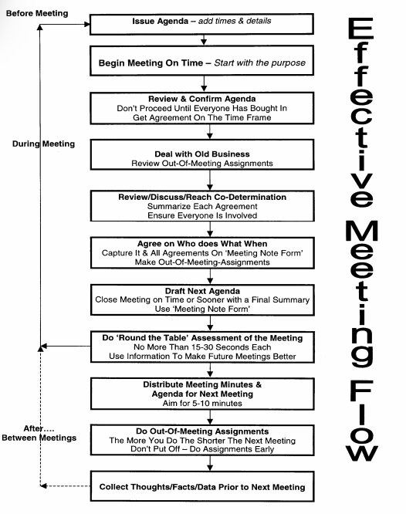

**Steps for an Effective meeting**

1. **Notice of Meeting**

* Let everyone involved know that you are requesting a meeting for a particular reason, and give them the date, time and location for this. This is known as a Notice of Meeting and can take the form of a memo, letter, poster and/or email communication.

Example Notice of Meeting in Memo format:

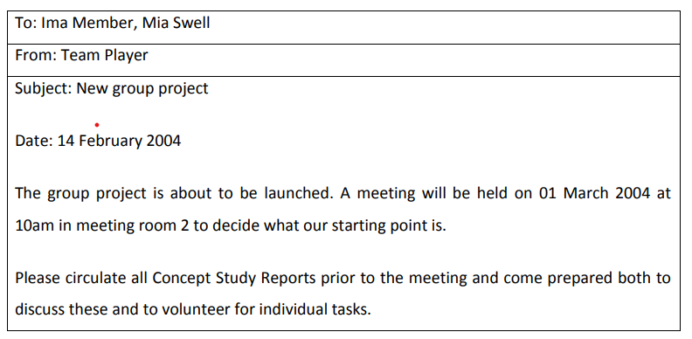

1. **Agenda**

* Before the meeting starts (sometimes given at the same time as the Notice of Meeting), you need to let all those invited to attend the meeting what it is that's to be discussed and the order that these items will be mentioned in.
* Known as an Agenda, this lets everyone prepare for the meeting in advance so that they can bring up any important points at the relevant time.
* An agenda for a meeting is a document given to all attendees before the meeting that lists, in order, the matters to be discussed. Also known as: *order of business* or *meeting timetable*.
* An agenda is more than just a list of things to do. An agenda is a meeting program designed to allow all relevant topics to be dealt with in good order and in good time.
* An agenda is like a map that shows how to get from one place to another, and how long each part of the journey will take.
* A formal agenda should always contain the following information:

1. The word Agenda

2. The name of the organisation, group or person calling the meeting

3. The date and time of the meeting

4. The meeting venue

5. Apologies

6. Minutes of the Last Meeting

7. Matters Arising

8. Your meeting's topics listed one after the other

9. Any Other Business

10. Date and Time of Next Meeting

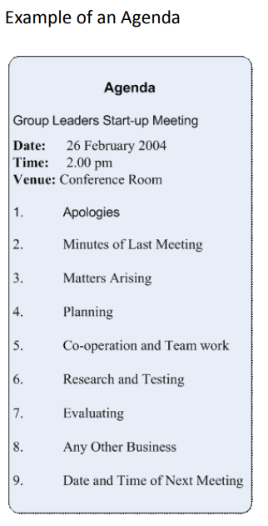

1. **Minutes**

* During the meeting itself, it is important that all points raised are noted so that a summary of the full meeting is recorded. These are the Minutes and they should show what was discussed, more especially what was agreed (or ruled out), and any action points - a note of something that has to be carried out, by whom, and usually with a deadline.
* Like the Notice of Meeting and Agenda, the Minutes should contain some fixed information and follow a standard layout.
* The headings in the Minutes should follow those in the Agenda for this meeting, after stating:

1. The name of the meeting

2. Its venue, date and time

3. Who was in attendance

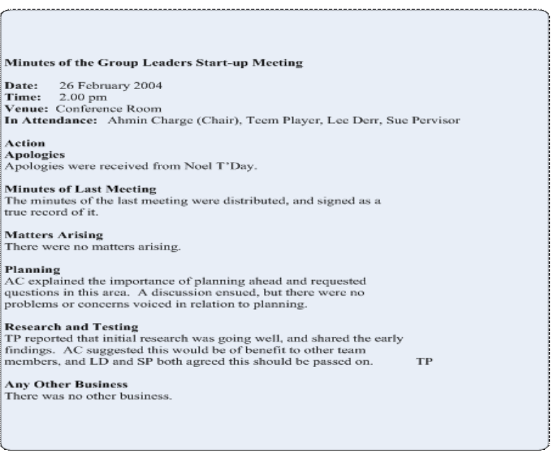

**MEETING PARTICIPATION TIPS**

* As a member of the team, it is also important to keep participation skills in mind. If you find meetings boring and time wasting, perhaps you can turn them around by making meetings more constructive for yourself.

1. Study the agenda and prepare yourself for the topics to be discussed. Make a point of having something to contribute.

2. Sit beside members you do not normally associate with. Don’t stay too close to your buddies, as this tends to establish sub groups within the team.

3. Keep an open mind. Free yourself from either positive or negative biases toward the speaker or the subject.

4. Take notes, jot down questions as they occur to you, and make a point of raising those when it is your turn to speak. Remember key ideas.

5. Ask questions. The right question can bring an entire meeting to life.

**Goals of a Meeting**

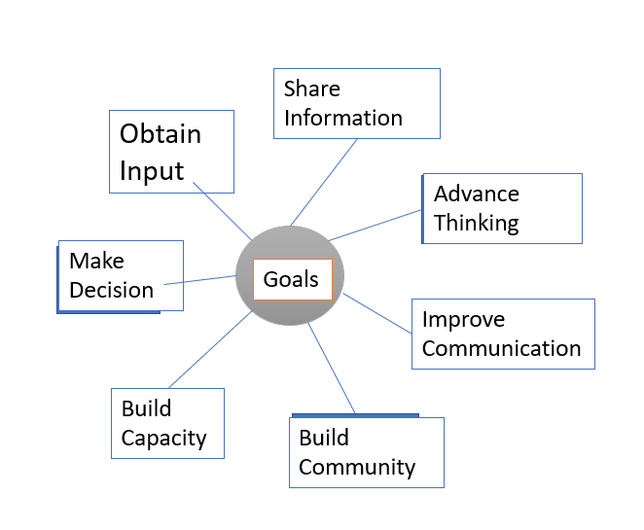

Mobile Phone Etiquette 

**Etiquette refers to good manners which help an individual find his place in the society**. It is essential for an individual to behave in a certain way for others to respect and appreciate him.

Etiquette refers to a set of rules individuals need to follow to be accepted in the society. One must understand the difference between college and professional life. Never adopt a casual attitude at work. It is important to be serious and a little responsible at the workplace.

Remember you are not the only person in organization; there are other people as well. You need to respect each other’s privacy and can’t afford to disturb others.

**Cell phone is a boon in today’s world but can be a disturbing element if not used in the appropriate way**. It tends to distract the person using it as well as others who are around.

**Mobiquette (Mobile Etiquette)**

**Mobiquette refers to certain guidelines that individuals need to adhere to while using the hand phone at the workplace**.

Things are quite different at home or a friend’s place, but one needs to be careful at the workplace.

* **Always keep your cell phone in the silent or vibration mode at the work place**. Loud ring tone disturbs employees who are around.
* Remember office phone is only for official purposes. **Don’t circulate your official number amongst all your friends and relatives**. Keep a separate phone for personal use. Making personal calls from official phone is simply not expected out of a sensible professional.
* Don’t activate film songs or jokes as caller tunes for mobiles meant for official use. It leaves a bad impression on clients or external parties who might call you.
* **Never shout on the phone**. Always be soft and polite. Avoid using abusive or foul language.
* Be careful with your phone. Never leave it at other’s workstations. It would waste yours as well as your colleague’s time. Try not to carry cell phone to restrooms.
* **Greet the other party well**. Start your conversation with a warm “Hello”. The way you talk matters a lot in verbal communication. The other party can’t see you; it’s your tone which makes the difference.
* Speak clearly. **Never chew anything while speaking over the phone**. It is important to concentrate while attending an important official call.
* Be clear about what you intend to communicate. It is advisable to keep related documents handy. Don’t make the other person wait. Always keep a notepad and pen with you to jot down important points.
* **Make sure your mobile calls do not hamper your productivity**. Don’t go for long personal calls at workplace. Be crisp and precise.
* It is bad manners to pick calls when someone is sitting with you unless and until it is an emergency.
* Extension fixed phones are meant to be used by everyone at the workplace. Don’t treat it as your personal property.
* **Avoid calling any of your clients or colleagues before 8 in the morning and after 8 in the evening**. The other person might be busy with his family or friends and definitely would not pay attention to your conversation.
* Switch off your mobiles while attending important meetings, presentations or seminars. In case of an emergency, move out of the place to attend the call

Cell phones are a fact of life in the 21st Century, and learning how to use them correctly will go a long way in determining how much of a civilised  person we are. Consider some instances below.

**1. At a Dinner Table**

The most common phone-related mistake tend to happen during meal time. This is true whether you’re eating at home or at a restaurant.

**Do’s**

* Keep phone usage down to an absolute minimum. Engage with the other people at the table; don’t just stare down at your phone the entire time.
* Set your phone to silent or vibrate mode as to avoid disrupting the other diners with a loud ring tone.

**Don’ts**

* Don’t use the flash function if you are going to take pictures of your food.
* Don’t answer an incoming call at the table. Instead, excuse yourself from the table if it’s urgent and accept the call in another room.

**2. At the Movies**

**Do’s**

* Put your phone in silent mode upon entering the auditorium. Better still, just turn your phone off.
* Keep your phone in your pocket or purse for the duration of the film.

**Don’ts**

* Don’t take phone calls before or during the movie. Leave the auditorium if you must take a call.
* Don’t text or email during the movie because the illuminated screen can be a major distraction for others.

**3. In Other Public Areas**

A phone is a communication device, so people are expected to use it in public spaces. Even so, good manners and common courtesy still apply.

**Do’s**

* Watch your language, particularly when in the presence of children. Avoid discussing overly private matters as well.
* Try to maintain some distance from strangers when taking a phone call. Try to keep a reasonable distance.

**Don’ts**

* Don’t use the speakerphone function in public unless everyone present wants to be included.
* Don’t talk in an elevator, on public transit, in public restrooms, or in other small spaces. Don’t take calls in quiet spaces like libraries, museums and places of worship either. Go outside or to some other area where you won’t disturb anyone else.

**4. While on the Road**

Phones are used for a lot more than just voice calls, and proper etiquette must be maintained when participating in other activities too, like playing games or chatting over an instant messenger.

**Do’s**

* Be aware of your surroundings. Try not to get in the way of other people as they go about their day.

**Don’ts**

* Don’t use your phone while participating in activities with other people. An example is a group discussion.
* Don’t play mobile games in public with the speaker on. Use headphones or mute the game’s sound.
* Don’t send or read text messages while walking. You could accidentally run into someone or something.

**5. At Home**

While the rules of cell phone etiquette aren’t as strict when you’re relaxing in the privacy of your own home, you should still show some courtesy to the other people in the house.

**Do’s**

* Leave the room to take a call if you are watching television or socializing with other people.
* Ask before using someone else’s charger or charging station.

**Don’ts**

* Don’t talk too loudly if you know other people might be sleeping.
* Don’t use your phone in bed if the room is dark and your partner is trying to sleep because the lit screen can be annoying. Go in another room to use it.

**6. Text Messages**

Most rules and considerations for cell phone etiquette apply when you’re in the presence of others, but there are also rules pertaining to how you choose to communicate with your phone.

**Do’s**

* Reply via text message if a person texts you. Use the same form of communication as he or she used to contact you, whether it’s by email, phone call or instant message.
* Respond to text messages in a reasonably timely manner, even if only to acknowledge receipt.

**7. Borrowing a Phone**

If you must borrow a phone from a friend or a stranger, be mindful of your manners and remember to say thank you.

**Do’s**

* Use the phone for exactly what you asked for in the first place.
* Keep your phone call as brief as possible.

**Don’ts**

* Don’t swipe around to see other pictures when someone wants to show you a particular picture on their phone. Doing so would be an invasion of privacy.
* Don’t take the phone out of someone’s hand when she wants to show you a picture unless it is clear she is offering you her phone

**Voice Modulation**

It refers to how you control your voice when speaking.  When we speak, we are able to change the message by varying th : tone, stress on words, pitch, and changing the rate of speech.

Effective voice modulation can mean the difference between a boring speech, and an audience captivating speech. However, modulation is not easy, and needs to be practised.

Focus on how you speak to people in an individual setting, the shift in pitch and the tone of your voice.  You can modulate your voice by:

i) Varying the pitch of your voice: Females tend to have a higher pitch of voice, due to different anatomical structuring. When delivering speeches, tend to stick to lower pitches. Microphones are deceiving, as you may think it amplifies your voice. They do amplify voice, as well other articulatory mistakes, higher pitches and breathing! So next time you have a speech using a microphone, practice with it first.

ii) [Speaking slowly](https://www.youtube.com/watch?v=KH9Nu82PaCQ): I cannot emphasise enough, the power of pausing. When you pause, you are able to catch your breath.  Your pauses will also make your audience lean forwards in their chair, and wait eagerly for your next message. Pausing is the best way to improve audience involvement and attention.

iii) Stress on certain words : When you increase emphasis or stress on certain words, you draw your audience’s attention. Choose powerful words to stress on, so that your message is captivating and clear.

iv) Speak quietly : Use this effect when you want your audience to calm down, or to hang to your every word. A certain way to grab the attention of someone, is through an assertive voice, rather than a loud authoritative voice.

v)Copy others : Look at videos of powerful orators, politicians, celebrities etc.  Observe the way they modulate their voices. Practice, practice, practice!

Components

* 1. Pitch
* Pitch is how high or low your voice is. We all have a natural pitch and many of us keep within a relatively small range of pitch when we speak.
* However, when you present, you can increase this range to add interest to your voice.
* Speaking in a higher pitch can show that you are scared of something. By contrast, speaking in a deeper voice can convey a sense of authority.
  1. Pause
* Pause refers to the breaks we take in our sentences. We pause for many reasons. A few are at a comma, at a full stop etc.
* Pauses help your audience understand you.
* Pauses help convey emotion.
* Pauses control the overall pace of your delivery.
* Pauses replace filler words.
  1. Pace
* Pace is your speed. for example, if you are nervous or scared, you speak very fast, if you are relaxed, you speak in normal or controlled pace.
* The goal is to speak at a conversational**pace.**
* Varying your pace helps keep your audience interested.
* Your pace affects your audience's ability to follow what you are saying.
* Your pace shows your passion for your subject.
  1. Tone
* Tone is the emotion with which you speak. This is the most important part of modulation.
* Tones of voice must be authentic and honest
* Emotions in speaking are more important than words